
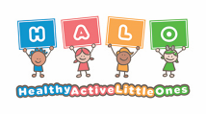
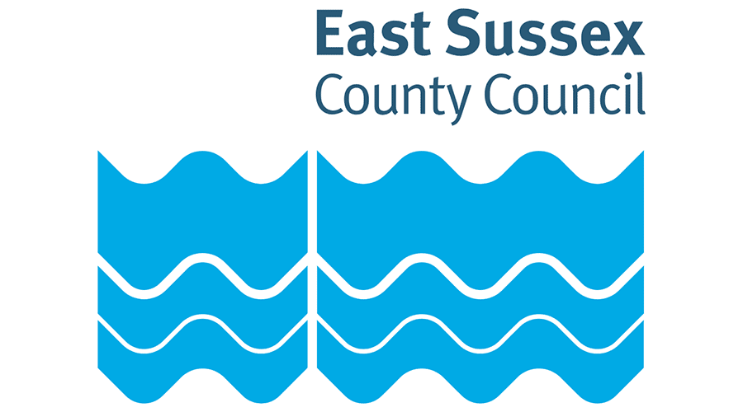

Healthy Active Little Ones
Oral Health

Table of Contents
(Please ctrl + click the contents to navigate the document)
Top tips for parents 1
Activity Ideas 2
Egg Scrubbing 3
Food Sorting 5
Brushing clean! 6
How many teeth? 7
Story sack ideas 8
Brush, Brush, Brush – Alicia Padron 9
How To Brush Your Teeth with Snappy Croc – Jane Clarke and Georgie Birkett 10
Dentist Trip – Peppa Pig 11
The Boy Who Hated Toothbrushes by Zehra Hicks 12
Book Ideas 14
Useful links 22
Guidance 22
General Information 22
Training 22

Top tips for parents

- Use a soft-bristled toothbrush designed for brushing a child’s teeth.
- Use a pea sized amount of toothpaste or a smear for very young children
- Start brushing your baby's teeth as soon as the first milk tooth breaks through. This is usually at around 6 months, but it can be earlier or later.
- Parents or carers should brush or supervise toothbrushing.
- Brush teeth twice daily for about 2 minutes with fluoride toothpaste.
- Brush last thing at night before bed and on 1 other occasion.
- Use children's fluoride toothpaste containing no less than 1,000ppm of fluoride or family toothpaste containing between 1,350ppm and 1,500ppm fluoride.
Why not try these apps to make tooth brushing more fun.
Brush DJ
Aquafresh brush time

Activity Ideas

Please use these HALO activity ideas in your settings and share with families for ideas to do at home.
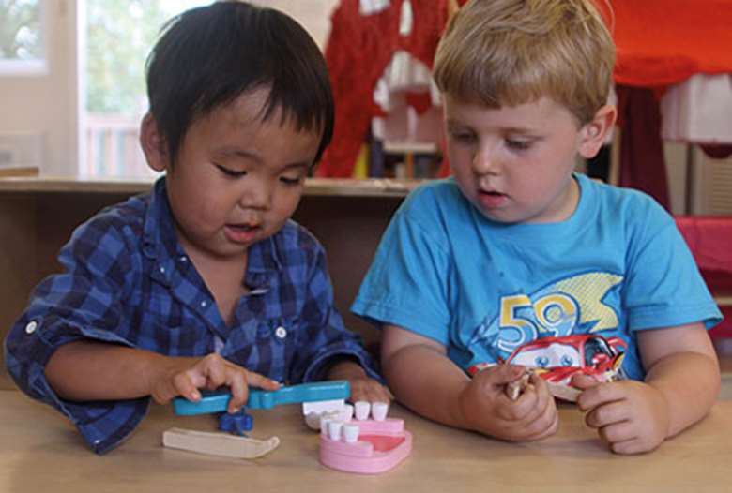

Egg Scrubbing

Activity:
- Label each cup with what liquid you will pour into each (e.g., one for coke, one for water, one for fruit juice, one for vinegar etc.)
- Start by putting your hard-boiled eggs into the cups. Let the children pour the fizzy drink over the top until they are completely submerged.
- Encourage the children to think, and make predictions, about what they think will happen to each egg.
- Leave the eggs to soak overnight (but no longer).
- The next day remove each egg from its container and pop it in an egg cup.
- Encourage the children to observe and talk about what they see and what has happened. Get them to use their senses to talk about how the egg looks, smells, feels etc.
- Using a toothbrush and toothpaste try to scrub the eggshells clean (as if brushing your teeth).
- Talk about what you have learned and what drinks might be better and healthier for our teeth.
Resources:
- Coke
- Lemonade
- Vinegar
- Water
- Fruit juice
- 5 hardboiled eggs
- 5 egg cups
- Sticky labels
- Toothbrushes and toothpaste

Skills to develop:
- Learning about healthy drinks.
- Thinking: predicting.
- Language: talking about what they see happening and using different descriptive words.
- Learning about the importance of oral health and hygiene.
You could extend this by:
- Make a sugar display.
- Read books about oral health.
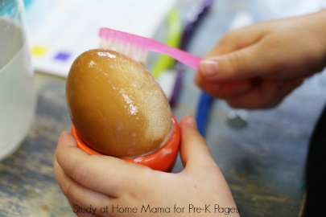

Food Sorting
Activity:
- Cut out a range of different food pictures and place them on the table or on a tray all mixed up.
- Make 2 large teeth pictures: label one with a happy face and one with a sad face.
- Encourage the children to choose a picture from the food pile. They then decide if it is a food that is ‘good for your teeth’ (if so, place it on the happy tooth) or ‘bad for your teeth (in which case, place it on the sad tooth).
- Talk to the children about their reasoning for why something is good or bad for their teeth. Ask them about how they can keep their teeth healthy and talk to them about toothbrushing.
Resources:
- Food pictures (either printed off the internet or cut out from food magazines)
- 2 sheets of white A4 paper and a marker pen
Skills to develop:
- Introduce ideas about sugar content and healthy food choices.
- Language: talking about why a food is good or bad for our teeth.
- Learning about the importance of oral health and hygiene and the importance of tooth brushing
You could extend this by:
- Making a display for your setting out of the resources.
- Downloading and using the food scanner app to see how much sugar is in their favourite foods NHS Food Scanner – Apps on Google Play
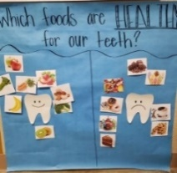

Brushing clean!
Activity:
- Cut out and laminate some white teeth pictures.
- Use the whiteboard marker to colour dirty patches on the teeth to resemble food and bacteria.
- Encourage children to practice brushing by using the brushes to clean off the whiteboard marker from the ‘teeth’.
Resources:
- Several teeth shaped laminated pictures (template available here)
- Whiteboard markers
- Toothbrushes
Skills to develop:
- Talk about correct brushing techniques (circular motion as well as back and forth)
- Introduce that toothbrushes are also for brushing our gums to keep them healthy.
- Learn about the importance of oral health and hygiene and the importance of tooth brushing
- Talk about the children’s brushing routines at home e.g., when and who helps them.
You could extend this by:
- Setting up a role play dentist.
- Using Lego or Duplo bricks and whiteboard markers to show how to brush food from between teeth.
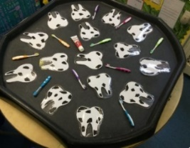

How many teeth?
Activity:
- Print and laminate the numbered teeth templates and set out.
- Give each laminate a ball of white playdough.
- Get the children to recognise the number on each mouth picture and to make the correct number of ‘teeth’ from white playdough to put in that mouth.
Resources:
- Number teeth laminate templates (available here)
- White playdough
Skills to develop:
- Number recognition and counting
- Fine motor skills from manipulating playdough.
- Learn about the importance of oral health and hygiene and the importance of looking after our teeth and how we do this.
You could extend this by:
- Using playdough to build a model mouth.
- Setting up a role play dentist.
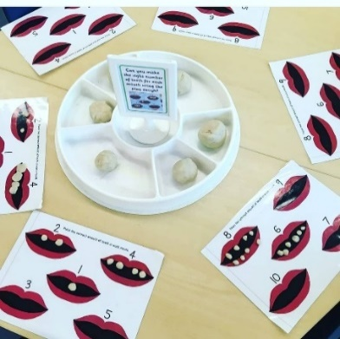

Story sack ideas

Please use these HALO ideas to help create story sacks and take-home bags in your setting to share with families.

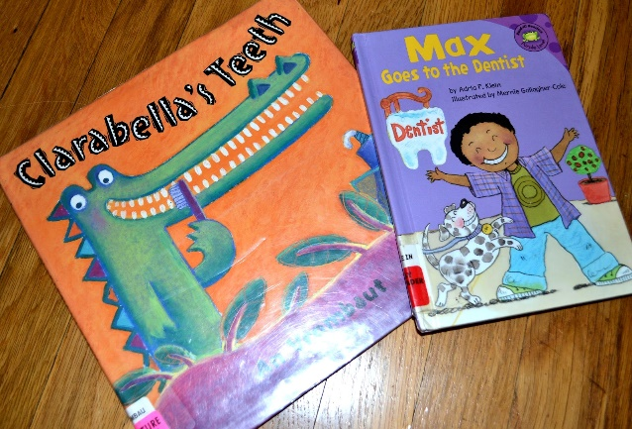

Brush, Brush, Brush – Alicia Padron

ISBN: 978-0-531-25236-9
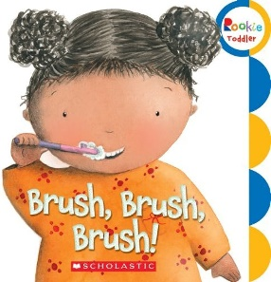
Resources:
- A collection of different toothbrushes (green, blue, stripy, spotty, adult sized, baby sized, animal shaped, character shaped).
- Play soap/shaving foam (check for allergies).
- Paint.
- Toothbrush mug or cup.
- Mirror.
Possible activities
- Talk about the collection of toothbrushes. Use colour names, size, patterns and pictures to describe the toothbrushes.
- Talk about how to brush your teeth – what do you need to do first, next?
- Talk about the action words for brushing your teeth (up, down, left, right, swish). Use a toothbrush to show what the actions look like.
- Use toothbrushes and play soap or shaving foam or paint to make the movements of the action words (up, down, left, right, swish).

How To Brush Your Teeth with Snappy Croc – Jane Clarke and Georgie Birkett

ISBN 978-1-782-95395-1
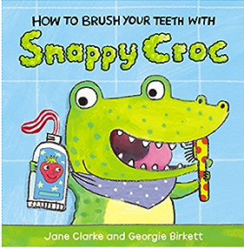
Resources
- Collection of soft toys or puppets (crocodile, bear).
- Collection of different toothbrushes. (Green, blue, stripy, spotty, adult sized, baby sized, animal shaped, character shaped).
- Play soap/shaving foam (check for allergies).
- Mirror.
Possible activities
- Talk about the collection of toothbrushes. Use colour names, size, patterns, and pictures to describe the toothbrushes.
- Talk about the different body parts where the toy or puppet wants to “squidge” the toothpaste. Where would be the best place? What else could the toy or puppet use to help them wash themselves?
- Use the toothbrush and “toothpaste” (play soap/shaving foam) to help the soft toy brush their teeth.
- Explore making different faces in the mirror. Smiling, happy, sad, frown, angry, stick your tongue out.

Dentist Trip – Peppa Pig

ISBN: 97-1-4093-0193-6
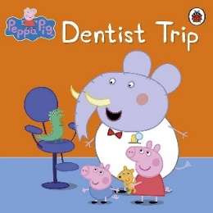
Resources
- Soft toys – pigs, teddy, crocodile.
- Collection of different toothbrushes. (Green, blue, stripy, spotty, adult sized, baby sized, animal shaped, character shaped).
- Play soap/shaving foam (check for allergies).
- Dentist props – outfit, mirrors
Possible activities
- Talk about how to brush your teeth – what do you need to do first, next?
- Pretend to be a dentist and check the toys teeth. Use phrases and instructions like “Open wide, please”, “Lovely clean teeth”, “Strong, clean teeth”, “special pink drink”.
- Use the toothbrush and “toothpaste” (play soap/shaving foam) to help the soft toy brush their teeth.

The Boy Who Hated Toothbrushes by Zehra Hicks

ISBN: 978-0-230-74841-5
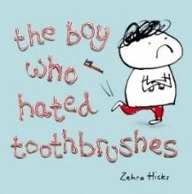
Resources
- Collection of different toothbrushes. (Green, blue, stripey, spotty, adult sized, baby sized, animal shaped, character shaped).
- Envelopes and paper, letter from the tooth fairy.
- Tooth sparkler (red sparkly toothbrush).
- Hat, small plastic ball.
- Paint, washing up liquid.
- Mirror.
Possible activities
- Talk about the collection of toothbrushes. Use colour names, size, patterns, and pictures to describe the toothbrushes.
- Make marks in a tray of paint or shaving foam. Talk about the shapes and patterns you can make – straight, up, down, circles, line, wavy, zig zag.
- Make up magic spells. Use rhyming words such as “dog, frog, log” or “cat, hat, mat”, words that begin with the same sound “cat, car, cow” or made-up words like “zog, mig, lit”. Write down or draw a spell.
- Paint with toothbrushes. Talk about the patterns and pictures.
- Make a drum kit from pots, pans and use your toothbrushes as drumsticks.
- Use your toothbrush to mix up water and washing up liquid to make bubbles.
- Write a letter to the tooth fairy and tell her what you’ve done with her tooth sparkler.
- Explore making different faces in the mirror – smiling, happy, sad, frown, angry, stick your tongue out.
Book Ideas
All these book suggestions are available to borrow for free when you sign up to the East Sussex Library service.
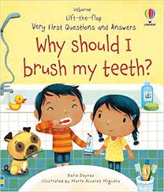
Name: Why Should I brush my teeth?
Author: Katie Daynes
ISBN: 9781-4749-6893-5 Age: 2-5
About:
Why don't animals have toothbrushes? Why do baby teeth fall out? Should everyone brush their teeth? Curious young children can discover the answers to these questions and many more in this entertaining book.
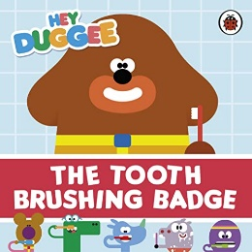
Name: The Tooth Brushing Badge - Hey Duggee
Author: CBeebies
ISBN: 978-1-405-944397 Age: 0-4
About:
It's a sunny day and Duggee and the squirrels are on a lovely walk until they meet a lion with very smelly breath. Join your favourite squirrels as they teach the lion a special song to help him learn how to brush his teeth..
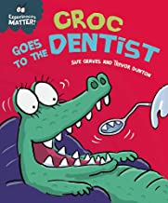

Name: Experiences Matter: Croc goes to the Dentist
Author: Sue Grave
ISBN:978-1-4451-7333-7 Age: 3-7
About:
This funny story is the perfect way to introduce young children to the idea of the dentist. Included are suggestions for activities and ideas to talk through together.

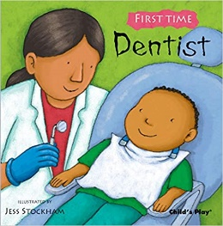
Name: First Time: Dentist
Author: Jess Stockham
ISBN: 978-1846433351 Age: 2-5
About:
What will happen? Will it hurt? Will you stay with me? Reading Dentist with your child is the perfect opportunity to talk about these questions. Young children’s lives are full of new experiences and these books help make them less scary. The simple text is designed to encourage further dialogue between reader and child. Use this book as a starting point to talk to your child and help them to prepare for these events and share any worries they may have.
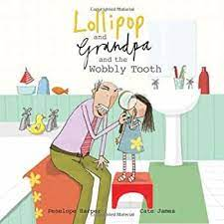
Name: Lollipop & Grandpa and the wobbly tooth
Author: Penelope Harper
ISBN: 978-1907912146 Age: 4-7
About:
Lollipop has her first wobbly tooth. It wibbles and wobbles, but it won't come out. Grandpa has come up with several ingenious ideas for sorting out wobbly teeth. But when his plans involve a tug-of-war match even Lollipop has to admit that grandpa might have lost the plot this time... Humorous, warm family fun.
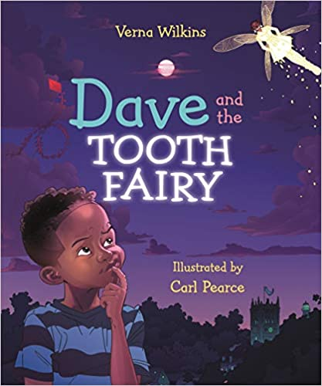
Name: Dave and the Tooth
Author: Verna Wilkins
ISBN: 978-1787415409 Age: 4-7
About:
Dave has a wobbly tooth. He wibbles and wobbles it, but it will not come out. But then one day Dave lets out an enormous sneeze and the tooth flies across the room and vanishes. Dave searches high and low, but it is nowhere to be seen. How will he get the tooth fairy to visit him now?
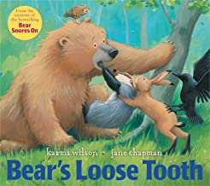
Name: Bear’s Loose Tooth
Author: Karma Wilson
ISBN: 978-0857073150 Age: 3+
About:
From a cave in the forest…came a "MUNCH, MUNCH, CRUNCH!" as Bear and his friend all nibbled on their lunch. Bear and his friends are munching on their lunch, when all of a sudden Bear feels something wiggling and wobbling in his mouth. Oh, no! What can it be? It's Bear's first loose tooth! Bear's friends help to ease his concerns about his wobbly tooth and help him understand losing a baby tooth is natural.
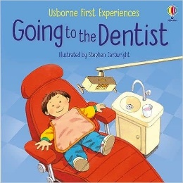
Name: Going to the Dentist
Author: Anne Civardi
ISBN: 978-1474995436 Age: 2-5
About:
Designed to introduce young children to the unfamiliar situation of visiting the dentist in an amusing and friendly way. An ideal starting point for young children and adults to discuss first experiences.
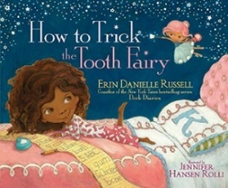
Name: How to trick the tooth fairy
Author: Erin Russell
ISBN: 978-1471160264 Age: 2-5
About:
Kaylee loves pulling pranks: from dropping water balloons on passers-by to tricking Santa Claus. Is she the Princess of Pranks? No! That title is held by none other than the Tooth Fairy. As Kaylee and the Tooth Fairy try to out-prank one another, things get way out of hand. Will the two finally see eye and eye and share the crown?
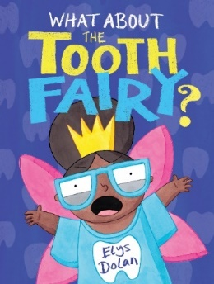
Name: What about the Tooth Fairy?
Author: Elys Dolan
ISBN: 978-1444948622 Age: 3-7
About:
Why doesn't the Tooth Fairy have a special day of her own?
Although she loves her job, sometimes she can't help but wonder why she doesn't have a day of her own. Soon the Tooth Fairy learns that for her day to be really special, she's got to do it her own way.

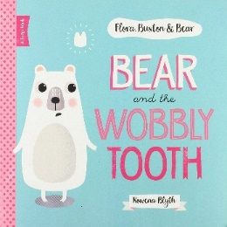
Name: Bear and the Wobbly Tooth
Author: Adam Bestwick
ISBN: 978-1910851630 Age: 0-4
About:
Bear has his first ever wobbly tooth. He's very keen to hold onto it until he discovers all about the magical Tooth Fairy. Now he's decided he wants it to fall out, his tooth might have other ideas.

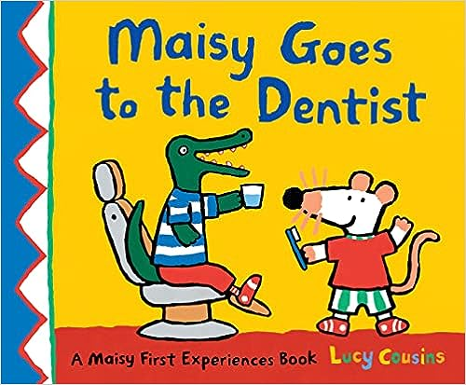
Name: Maisy goes to the dentist.
Author: Lucy Cousins
ISBN: 978-1529512625 Age: 3-7
About:
Join Maisy and her friends as they go with Charley on his first visit to the dentist. This story is ideal for preparing little ones for their first dental check-up.

Useful links

Guidance

- Government Guidance: Oral health - Help for early years providers - GOV.UK (education.gov.uk)

General Information
- Advice NHS - Children's teeth - NHS (www.nhs.uk)
- Find a Dentist: https://www.nhs.uk/service-search/find-a-dentist
- Dental Emergency: How can I access an NHS dentist in an emergency or out of hours? - NHS www.nhs.uk)
- Dental Care for babies: Looking after your baby's teeth - NHS (www.nhs.uk) - Includes information around dummies.
- Dental Treatment and Special Needs: Dental care for people with special needs - Oral Health Foundation (dentalhealth.org)
- Dental check by 1

Training

The Healthy Active Little Ones team offer an Oral Health training.
The aims of this session are:
· To enhance the setting’s knowledge of appropriate oral health practices.
· To provide practitioners with the knowledge and tools to support families with oral health.
If you would like to book your setting onto this training session, please contact the HALO team. They can provide available dates and book your space.
Email: Healthyactivelittleones@eastsussex.gov.uk

