Language Through Play – home ideas
Top tips and activities to support your child’s speech, language, and communication.

Top Tip
Communication is key to helping children understand something new, so start talking about nursery at home. Story books and photos can support children’s understanding of something new and unfamiliar.
Exploring books about going to nursery can provide a starting point for conversations.

Story
Lulu loves Nursery, by Camilla Reid
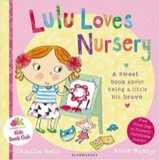

Activity
Try these games to support listening and attention skills in preparation for the nursery environment.
“Simon Says…” (You can change this to Mummy/Daddy says…)
Listening walk (what can you hear as you are out walking/in the park)
Musical bumps/statues
Make subtle mistakes as you sing or read and see if your child spots the mistake.

